**EX.NO:2 COMPUTING THE SIGMOID AND TANH VALUES**

**DATE:23/2/24 USING NUMPY**

**AIM:**

To compute their sigmoid and tanh (hyperbolic tangent) values using NumPy and plot the values.

**INTEGRATED DEVELOPMENT ENVIRONMENT (IDE) REQUIRED:**

JUPYTER NOTEBOOK

**REQUIRED LIBRARIES FOR PYTHON:**

* Numpy
* MatplotLib

**PROCEDURE:**

**STEP 1:** Import required libraries

**STEP 2:** Write code to define the sigmoid function.

**STEP 3:** Write code to define the tanh function.

**STEP 4:** Generate a random array of values using numpy

Random_values = np.random.randn(no of values)

**STEP 5:** Calculate the sigmoid and tanh (hyperbolic tangent) of these random values.

Call sigmoid function return 1/(1+np.exp(-x))

Call tanh function return np.tanh(x)

**STEP 6:** Plot the values

**PROGRAM:**

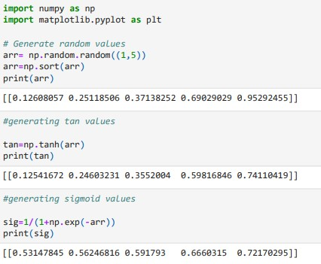

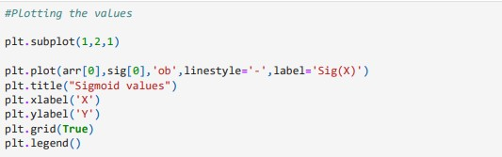

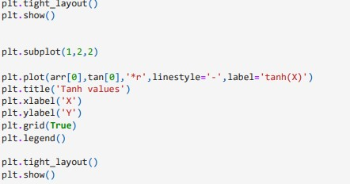

**OUTPUT:**

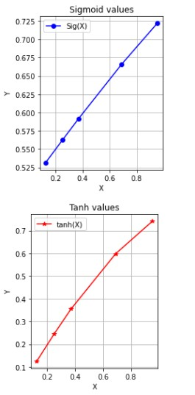

**RESULT:**